IPEX -> MRPMFG -> MRP Actions -> Routing Maintenance (SECRET)

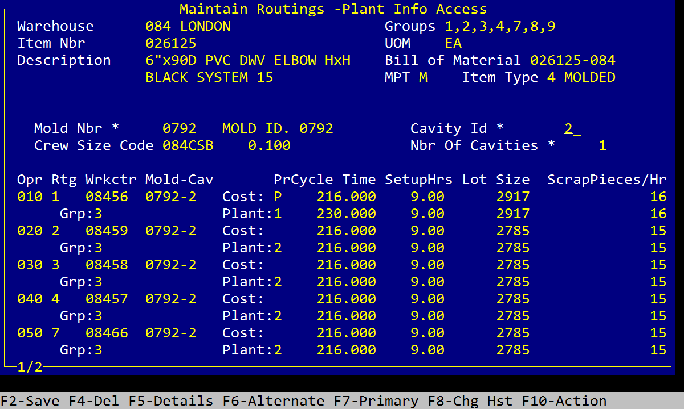

IPEX -> FIN -> Costing -> Engineering -> Work Centers -> MOLD Maintenance

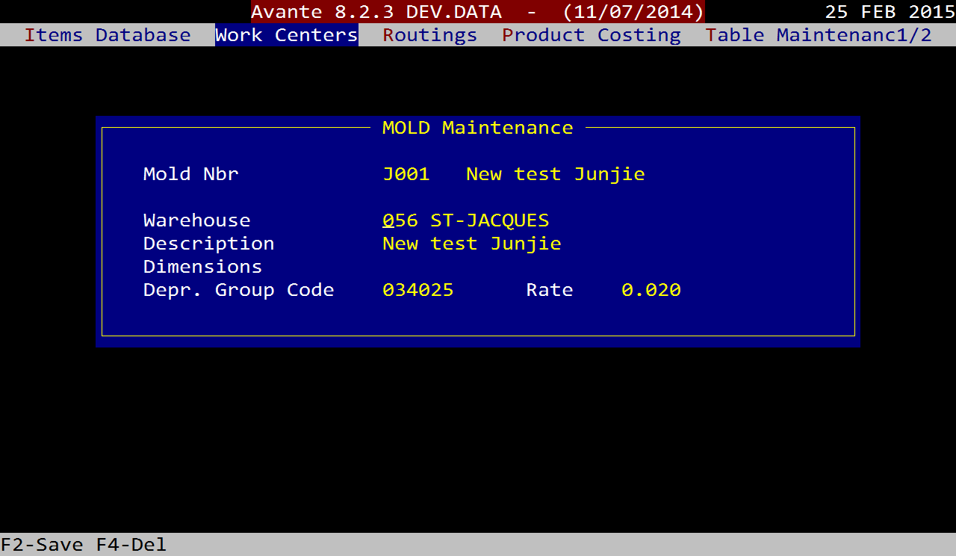

IPEX -> FIN -> Costing -> Engineering -> Routings -> Routings Maintenance

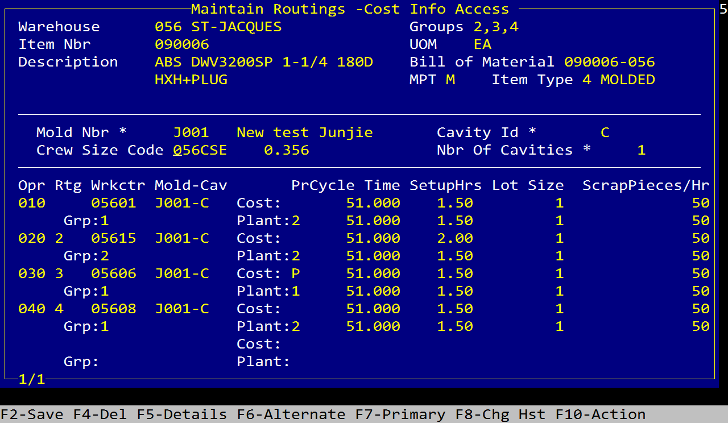

IPEX -> MRPMFG -> MRP Actions -> Routing Push to MES

WCR3003C

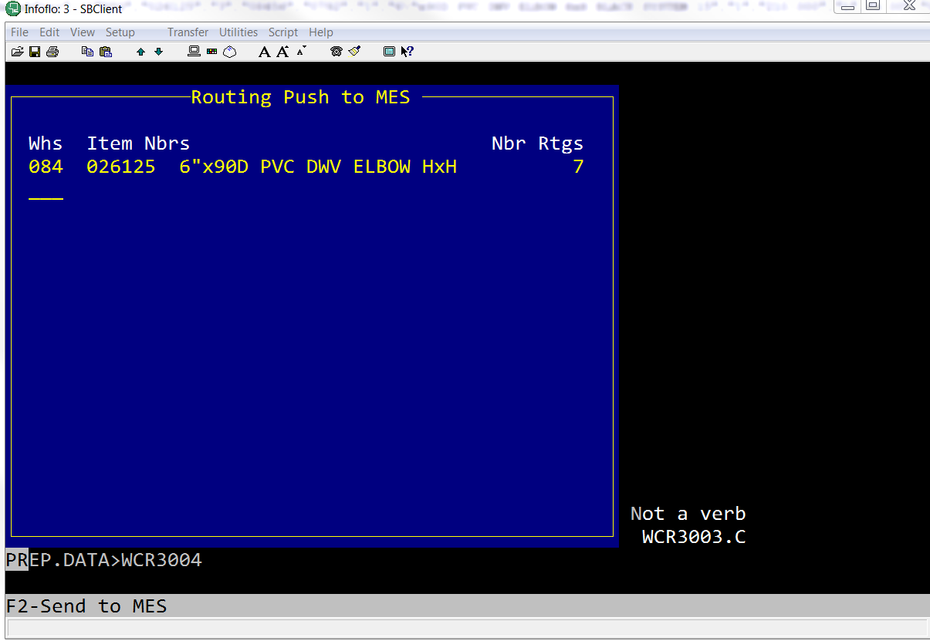

Key = Mold#\*CavityID

MRP8006 (MRP Scheduler Workbench) -> F4 MES

F6-Resched

08452